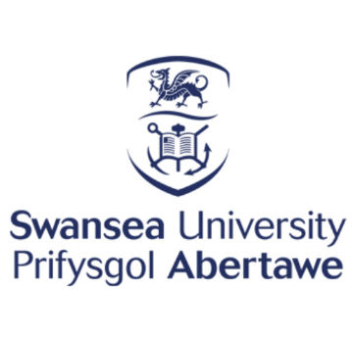

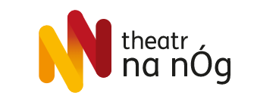

NEWS | 23 February 2022

Theatr na nÒg open their doors to students of Italian at Swansea University
by Giovanna Donzelli

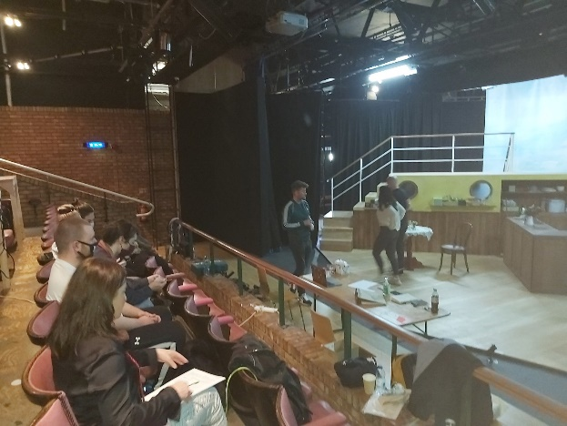
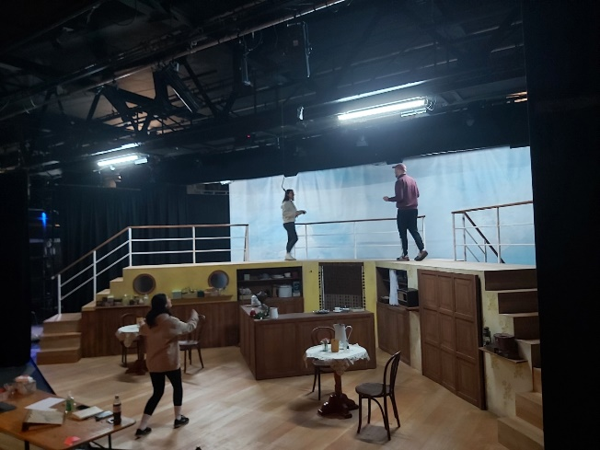

This week, several final-year students studying Italian at Swansea University were invited as language consultants at the Dylan Thomas Theatre to assist with Theatr na nÒg’s not-to-be missed performance: Arandora Star, Theatr na nÓg Production: Arandora Star - Technocamps; Theatr na nÓg | Facebook

Emma Burton, Owen McCormack, Madi Neil and Donovan Ruiz, accompanied by their lecturer and Departmental Lead for the Teaching Pathway (Modern Languages) Dr Giovanna Donzelli met with Theatr na nÒg’s talented cast, and worked with the actors to fine-tune their Italian pronunciation, rhythm and opera lines, in view of the opening season next week!
The Arandora Star is a bilingual Welsh-Italian/English-Italian production which tells the story of the Italian communities living in Wales during WWII.
Dr Donzelli: “When I first moved to South Wales, I was gifted with a beautiful book, with an unusual title, Lime, Lemon and Salsaparilla* which helped me understand why coffee was so good here, the life-journey of many fellow Italians to South Wales and their influence on Welsh society.
“Before then I had never heard about the story of the Arandora Star that Theatr na nÒg encourages us all not to forget. This is the story of a beautiful friendship between countries, cultures, and languages that gets destroyed by the war but slowly rebuilt, on stage as in life, by the determination to see beyond our differences and see in the ‘foreigner’ an opportunity to expand our horizons and learn.”
Donovan: “I felt very honoured that this group requested our help for their performance of the Arandora Star. As university students, opportunities like this are invaluable for gaining more practical experience in our field.”
Emma: “Using my Italian to help the actors was an amazing experience. It offered me the challenge of understanding sung Italian, but also to apply what I have learnt throughout my degree to a practical situation. As I speak Welsh, the combination of the three languages almost synchronously [in the play] made me realise how similar Welsh and Italian are and how well they flow together.”
Madi: “The visit to the Dylan Thomas Theatre last week was a really interesting experience that put our Italian knowledge to the test when helping the actors of Arandora Star perfect their pronunciation and expression of Italian lines present throughout the play.”
Owen: “The experience put into perspective how a knowledge of foreign languages can benefit people working in the arts. It was fantastic to see the actors engaging with our feedback with such enthusiasm and professionalism.”

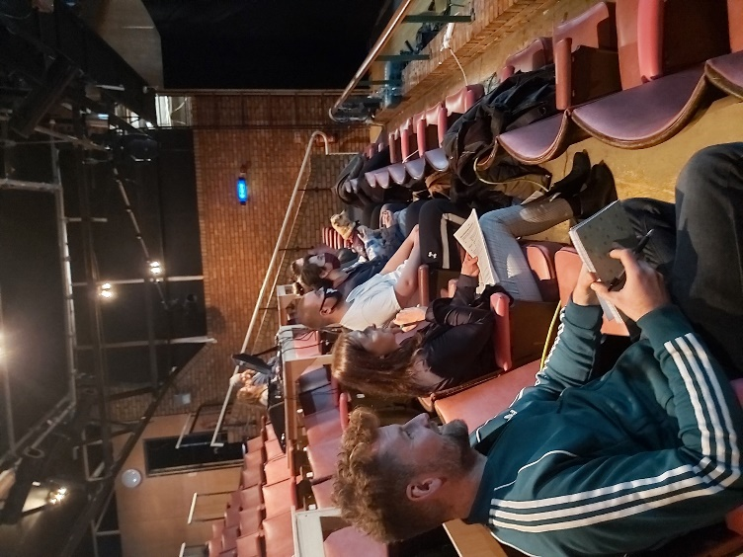
Thanks to this successful collaboration, Theatr na nÒg and Modern Languages at Swansea University are planning to expand their placement opportunities, within the Teaching Pathway, with exciting projects for all students of French, German, Italian, Mandarin and Spanish. Students will be engaging, for example, in the design and production of dedicated Modern Foreign Languages e-materials for schools to support multilingualism and to share with young people their passion for languages, as a bridge between cultures and a window to the world.

*Hughes, C. (1991). Lime, Lemon & Sarsaparilla. The Italian Community in South Wales 1881-1945. Bridgend: Seren Books.

